
SRBF F2
Information Technology Solutions

ABOUT THIS PRODUCT

LPF-2 Grade material is manufactured from medium weaved, cotton Fabric. The material of this grade has a superior machiningg and punching properties and better resistance of chemicals. Recommended for small parts
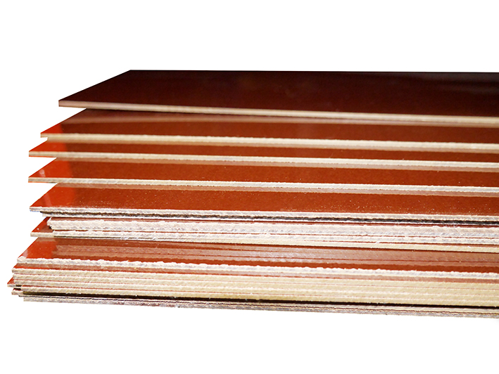

APPLICATIONS

• Rigid
• Strong in both directions
• Easily machined
FEATURES AND BENEFITS

• Rigid
• Strong in both directions
• Easily machined

23 Ullswater Crescent
Coulsdon
Surrey
CR5 2UY
TEL: +44(0) 20 8668 1481
WEB: www.croylek.com
EMAIL: sales@croylek.co.uk
MATERIAL DATA

Grade | LRF- 2 (F2)
Thickness | 0.4mm-150.0mm
Size | Standard sizes are 2440 x 1220 / 1220 x 1220mm
Specifications Met | BS:2572: GRADE F2/EN-60893-3-4-PFCC203  DIN7735-GRADE HGW 2083  DIN:7735 GRADE HGW:2082.5

TECHNICAL TABLE

Properties | Units | Average | Values as per test results IS:2036-1995
Mechanical:
Tensile Strength | Kgf/cm² | 700 | --
Flexural strength/Cross
Breaking Strength | Kgf/cm² | 1200 | 1100 Min.
Shear Strength | Kgf/cm² | 745 | 650 Min.
Impact Strength (Edgewise) | KJ/m² | 9 | 7 Min.
Specific Gravity |  | 1.35 | ----------
Electrical
Electrical Strength in oil at 90°C
*Flat wide 1.6mm thickness | Kv/mm | 1.5 | 0.72 Min.
*Edgewise 3.2mm thickness | Kv | 4 | 1.0 Min
Insulation Resistance | Meg Ohms | 10 | 0.5 Min
After immersion in water.
For 24 hrs at 20°C

Water Absorption
*Thickness | mm | 0.8 | 3.0 | 12.0 | 25.0
*Maximum Value | mg | 201 | 245 | 324 | 420
Average Test Results | Mg | 68 | 89 | 112 | 154

